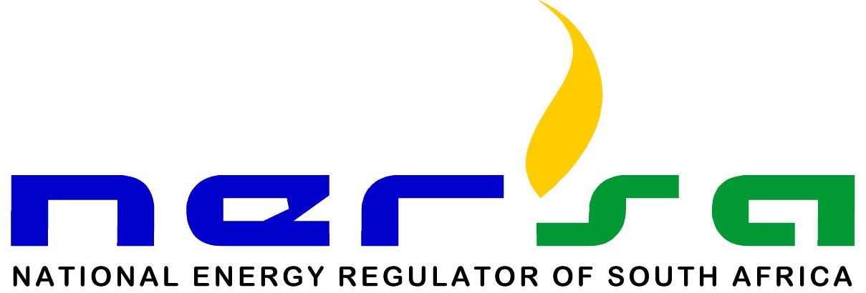

The National Energy Regulator of South Africa (NERSA) is a regulatory authority established as a juristic person in terms of section 3 of the National Energy Regulator Act, 2004 (Act No. 40 of 2004). NERSA’s mandate is to regulate the electricity, piped-gas and petroleum pipelines industries in terms of the Electricity Regulation Act, 2006 (Act No. 4 of 2006), Gas Act, 2001 (Act No. 48 of 2001) and Petroleum Pipelines Act, 2003 (Act No. 60 of 2003).

NERSA’s mandate is further derived from written government policies and regulations issued by the Minister of Mineral Resources and Energy. NERSA is expected to perform the necessary regulatory actions in anticipation of and/or in response to the changing circumstances in the energy industry.

The Minister of Mineral Resources and Energy appoints Members of the Energy Regulator, comprising Part-Time (Non-Executive) and Full-Time (Executive) Regulator Members, including the Chief Executive Officer (CEO). The Energy Regulator is supported by staff under the direction of the CEO.

Kulawula House, 526 Madiba Street, Arcadia, 0083
P O Box 40343, Arcadia, 0007
Tel: 012 401 4600 Fax: 012 401 4700
Website: www.nersa.org.za Email: info@nersa.org.za

@NERSA_ZA

@NERSAZA



